Unit 1: Lesson 5
Positive Feelings About Ourselves

Goal: To learn the part feelings about ourselves play in the Thoughts-Actions-Feelings Circle. To learn how our feelings about ourselves lead to more thoughts.

Story:
A smiling, green dinosaur seemed to wiggle a bit from the morning breeze. It was the third time Sam had used his lawn mower to create something original and fun. Before, he’d drawn a moon rocket and a sports car. Now his drawing was a brontosaurus that filled up a good chunk of the backyard.
A neighbor stopped by to tease him about mowing only part of the lawn. But it was a fun way to make friends. His uncles, aunts, cousins, and grandparents told stories about his rocket and his sports car. He felt good about getting the lawn mowed; he felt good about getting the dino details just right. He liked what he was doing, and he was beginning to like mowing the lawn.
Sam looked at his dinosaur and said to himself, “I feel happy today.”
Sam’s dad came out to chat with him. “Hey, buddy. You sure are having fun with your chores. What gives?”
“I figured out that when I just do them and stay positive, I feel good about myself. And I like mowing goofy stuff in the grass.”
Dad smiled and said, “That’s a pretty important idea to learn so young. Don’t ever forget it. If you stay positive your whole life, you’ll be a person you really like.”
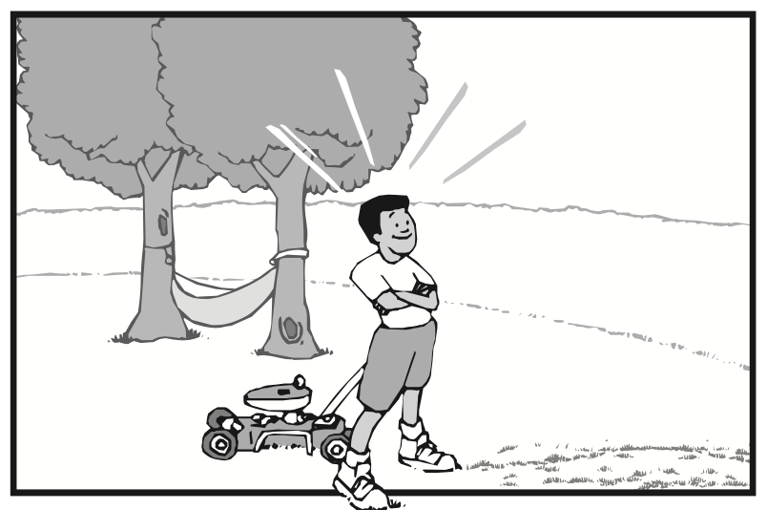
Let’s look at this Thoughts-Actions-Feelings picture. When we talk about feelings in the Thoughts-Actions-Feelings Circle, we are talking about the feelings about ourselves that result from our actions. It’s very important to us to feel good about ourselves. One of our most basic needs is to build and preserve our self-concept – how we think and feel about ourselves – because it influences everything in our lives.
More than anything, we all want to feel good about ourselves. Sometimes we do a good job of building and preserving our self-concept; sometimes we don’t. How we feel about ourselves depends on what we do. We feel good about ourselves only when we do positive actions, and we feel bad about ourselves when we do negative actions.
It’s important to be aware of the good feelings we get about ourselves when we do positive actions. We need to pay attention to those good feelings because they motivate us to think positive thoughts that lead us to do more positive actions.
The reward for doing positive actions is the good feeling we get about ourselves inside. Being aware of those good feelings internally motivates us to think more positive thoughts and to do more positive actions. When we do positive actions, we feel good about ourselves and our lives. It’s the Thoughts-Actions-Feelings Circle again! Our good feeling about ourselves is our reward – an internal reward – for doing positive actions.
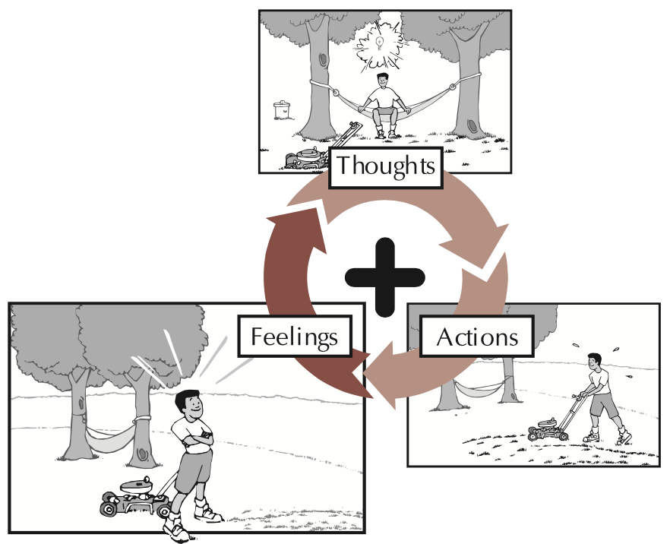
Sometimes we think that how we feel about ourselves depends on things outside of ourselves, such as money, popularity, power, or possessions. These external things can make us feel good about ourselves only if they come to us because we’ve done positive actions. Our internal reward – satisfaction from doing positive actions – comes first, and that is what makes us feel good about ourselves and want to do more positive actions. Then we enjoy the good things that come into our lives as a result. Doing positive actions is the only sure way to feel good about ourselves.
Sometimes we do negative actions and expect to feel good about ourselves. But then we realize that we feel worse about ourselves and that our negative actions affect others negatively. For instance, if we don’t treat others the way we want to be treated, then we’ll have conflicts with them. We don’t feel good about ourselves when we do negative actions, and those around us suffer from them, too.
Do you remember Sam from our story? Sam could have chosen negative actions. He could have been grumpy and refused to mow the lawn. Then he would have felt bad about himself. Sam learned that good feelings about himself come from doing positive actions. Sam enjoyed the good feelings he got about himself that resulted from willingly mowing the lawn.
The more positive actions we do, the better we feel about ourselves. When we pay attention to those good feelings, we’re motivated to think more positive thoughts and do more positive actions. The internal reward of feeling good about ourselves encourages us to continue growing.
Questions:
- How do feelings about ourselves in the Thoughts-Actions-Feelings Circle relate to self-concept?
- Why is the need to feel good about ourselves important?
- How do we get a good feeling about ourselves?
- How does what we do affect how we feel about ourselves?
- Why do we need to be aware of good feelings about ourselves?
- How did you feel about yourself when you did your positive actions last week?
- How do you feel about yourself when you do negative actions?
- Do you use any negative actions to try to feel good about yourself? Which ones?

Let’s look at the Thoughts-Actions-Feelings Circle one more time. See the word Feelings on the poster. Remember that the word Feelings on this poster refers to feelings we have about ourselves. Notice how our feelings follow our actions and lead to our thoughts.
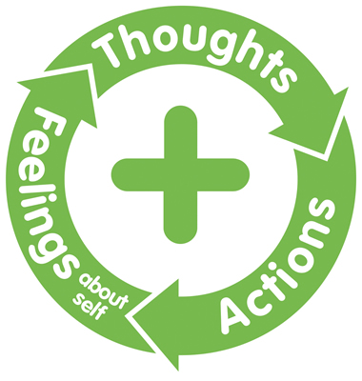
Think of how you felt about yourself when you did your positive actions last week. Take a minute to just be aware of the good feelings you enjoyed when you did your positive actions.
Now think of ways to express the good feelings you get about yourself when you do positive actions. You can draw pictures of yourself when you are happy or draw pictures of positive actions that make you feel happy. You can write a story or a poem or a song. Decide how you want to express your good feelings about yourself when you do your positive actions and share them with one another.
Parenting Positive action
Ask Yourself: As you did each of your positive actions for your children, how did you feel? How can you be more aware of the good feelings your get about yourself as a parent from doing positive actions for your children? How can you help your children recognize the good feelings they get about themselves from doing positive actions?

Plan and Do: Continue doing positive actions for your children this week, focusing on how you feel about yourself. Take time to pay attention to the good feelings your get from doing positive actions as a parent. Let these good feelings influence your relationship with your children. This is the week to be aware of how you feel about yourself as you do positive actions.

Family Discussion:
- How can we help one another be aware of the good feelings we have when we do positive actions?
- How can we reinforce one another’s good feelings that come from doing positive actions?

Now let’s choose two or three positive actions we can do as a family this week. Maybe we could plan a picnic with healthy foods? Maybe we could find a family to help? If everyone is really busy, maybe we could commit to eat dinner as a family at least twice during the week.
As we do these positive actions, let’s focus on the good feelings we get from doing them. Let’s think of some ways we can reinforce those good feelings. Can we give one another high-fives? Extra hugs and kisses? Let’s find creative ways to ask one another how we feel and celebrate the good feelings we have about our family.

COMMUNITY POSITIVE ACTIONS:
This week, as a family let’s choose to do a special positive action for someone we know, maybe a friend or child in our community who may need extra love or attention. Maybe we could send the child a special book or small toy, a kind card or letter, or some extra treats. Or maybe someone we know is ill or elderly and needs special attention. Again, let’s keep out positive actions a secret and just focus on the good feelings that result from doing a meaningful positive action.

SUMMARY:
It’s very important to feel good about ourselves: it’s one of our most basic needs and it influences everything in our lives. When we talk about feelings in the Thoughts-Actions-Feelings Circle, we are talking about the feelings about ourselves that result from our actions. It’s important that we be aware of the good feelings we get about ourselves when we do positive actions.
How we feel about ourselves depends on what we do. Sometimes we think that money, popularity, and possessions are things that will make us feel good about ourselves. Sometimes we think that negative actions will help us feel good about ourselves. But doing positive actions is the only sure way to feel good about ourselves. We need to pay attention to those good feelings because they motivate us to think more positive thoughts and to do more positive actions.
The internal reward of feeling good about ourselves encourages us to continue growing, to continue doing positive actions. We gain more and more confidence in our ability to take positive action no matter what comes our way.
We feel good about ourselves when we do positive actions.

Word of the Week: Unique
To be one of a kind.

